Kafka & Zookeeper

As known Kafka is dependent on Zookeeper(a distributed configuration Management Tool). Hence lets setup Zookeeper

**Zookeeper Installation**

1. Go to your Zookeeper config directory. For me its *C:\zookeeper-3.4.7\conf*

2. Rename file “zoo_sample.cfg” to “*zoo.cfg”*

3. Open zoo.cfg in any text editor.

4. Find and edit dataDir=/tmp/zookeeper to :\zookeeper-3.4.7\data

5. Add an entry in the System Environment Variables as we did for Java.

a. Add ZOOKEEPER_HOME = C:\zookeeper-3.4.7 to the System Variables.

b. Edit the System Variable named “Path” and add ;%ZOOKEEPER_HOME%\bin;

6. You can change the default Zookeeper port in zoo.cfg file (Default port 2181).

7. Run Zookeeper by opening a new cmd and type zkserver.

8. You will see the command prompt with some details, like the image below:

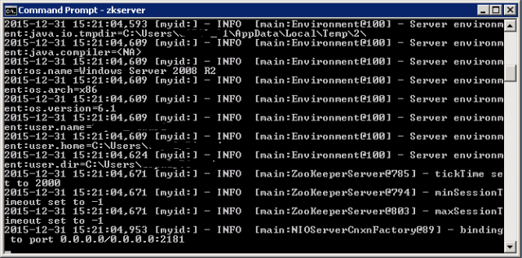

Now, your Zookeeper is up and running on port 2181

**Setting Up Kafka**

1. Go to your Kafka config directory. For me its *C:\kafka_2.11-0.9.0.0\config*

2. Edit the file “server.properties.”

3. Find and edit the linelog.dirs=/tmp/kafka-logs” to “log.dir= C:\kafka_2.11-0.9.0.0\kafka-logs*.*

4. If your Zookeeper is running on some other machine or cluster you can edit *“zookeeper.connect:2181”* to your custom IP and port. For this demo, we are using the same machine so there's no need to change. Also the Kafka port and broker.id are configurable in this file. Leave other settings as is.

5. Your Kafka will run on default port 9092 and connect to Zookeeper’s default port, 2181.

6. Add below lines to server.properties file

listeners=PLAINTEXT://127.0.0.1:9092

auto.create.topics.enable=true

**Running a Kafka Server**

*Important: Please ensure that your Zookeeper instance is up and running before starting a Kafka server.*

1. Go to your Kafka installation directory: *C:\kafka_2.11-0.9.0.0*

2. Open a command prompt here by pressing *Shift + right click*and choose the “Open command window here” option).

3. Now type .\bin\windows\kafka-server-start.bat .\config\server.properties and press Enter.

.\bin\windows\kafka-server-start.bat .\config\server.properties

Image title

4. If everything went fine, your command prompt will look like this:

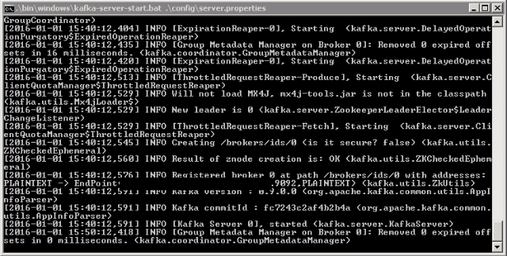  
5. Now your Kafka Server is up and running, you can create topics to store messages. Also, we can produce or consume data from Java or Scala code or directly from the command prompt.

**Creating Topics in Kafka**

1. Now create a topic with the name *“test”* and a replication factor of 1, as we have only one Kafka server running. If you have a cluster with more than one Kafka server running, you can increase the replication-factor accordingly, which will increase the data availability and act like a fault-tolerant system.

2. Open a new command prompt in the location *C:\kafka_2.11-0.9.0.0\bin\windows.*

3. Type the following command and hit Enter:

kafka-topics.bat --create --zookeeper localhost:2181 --replication-factor 1 --partitions 1 --topic test

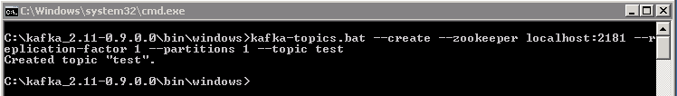

**Creating a Producer and Consumer to Test Server**

1. Open a new command prompt in the location *C:\kafka_2.11-0.9.0.0\bin\windows*

2. To start a producer type the following command:

kafka-console-producer.bat --broker-list localhost:9092 --topic test

3. Again open a new command prompt in the same location as *C:\kafka_2.11-0.9.0.0\bin\windows*

4. Now start a consumer by typing the following command:

kafka-console-consumer.bat --bootstrap-server localhost:9092 --topic test --from-beginning

5. Now you will have two command prompts, like the image below:

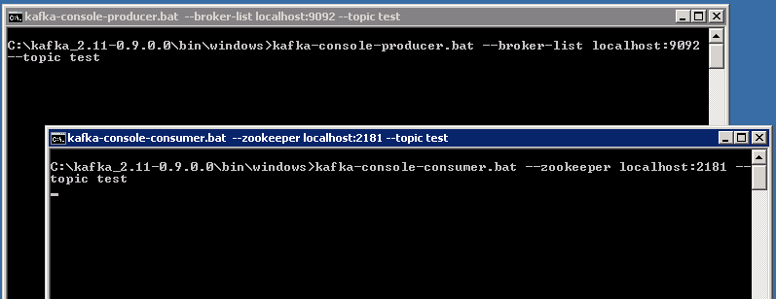

6. Now type anything in the producer command prompt and press Enter, and you should be able to see the message in the other consumer command prompt.

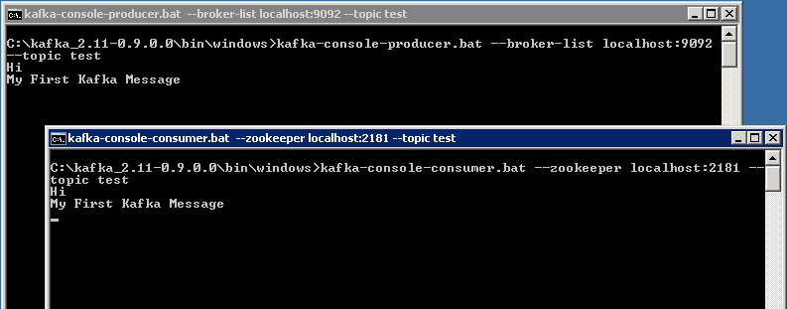

7. If you are able to push and see your messages on the consumer side, you are done with Kafka setup.

**Other Kafka Useful Tools:**

1. List Topics: kafka-topics.bat --list --zookeeper localhost:2181
2. Describe Topic: kafka-topics.bat --describe --zookeeper localhost:2181 --topic [Topic Name]
3. Read messages from the beginning: kafka-console-consumer.bat --zookeeper localhost:2181 --topic [Topic Name] --from-beginning
4. Delete Topic: kafka-run-class.bat kafka.admin.TopicCommand --delete --topic [topic_to_delete] --zookeeper localhost:2181